Jj d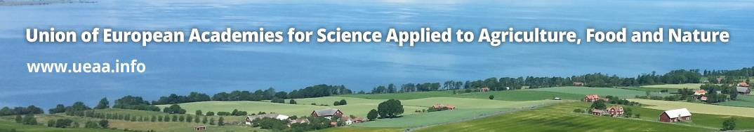

**Draft PROGRAM**

**of the XII th General Assembly of the Union of European Academies for Science Applied to Agriculture, Food and Nature (UEAA) and the associated Scientific Symposium**

**10-11 October 2024, Bucharest, ROMANIA**

| **Date** | **Time** | **Activity** |
| --- | --- | --- |
| **Thursday**  **10 October 2024** |  | **UEAA Steering Committee** **meeting** (**only** for Steering Committee members) |
|  | **UEAA General Assembly** **meeting and associated Scientific Symposium**  Welcome address:   * **Valeriu TABĂRĂ**, President of the *“Gheorghe Ionescu-Şişeşti”* Academy of Agricultural and Forestry Sciences * **Cristian HERA,** Honorary President of the *“Gheorghe Ionescu-Şişeşti”* Academy of Agricultural and Forestry Sciences * **Florin-Ionuț BARBU**, Minister of Agriculture and Rural Development of Romania   Opening Ceremony   * ***Elena HORSKA***, UEAA President   Administrative duties:  Election of the new President, Vice-President and Steering Committee members |
|  | 15 30 19 00 | **Scientific Symposium** *“***New research techniques and the agricultural progress*”***   * **Does genome editing have a future in EU agriculture?** (authors: Catherine Regnault-Roger, Alain Toppan et Michel Thibier – AAF) * **The role of synthetic hexaploid wheat in winter wheat resistance to leaf rust at NARDI Fundulea. (**autors: Matilda Ciuca, Alexandru Dumitru, Alina Turcu, Laura Contescu, Daniel Cristina – National Agricultural Research-Development Institute - NARDI Fundulea) * **Learning from hen’s physiology to improve the sustainability of egg production.** (author: Michel Duclos - INRAE) * **Morphological variability and mineral composition of three garlic genotypes cultivated in Korça region, Albania.** (authors: Pirro Icka, Robert Damo - University "Fan S. Noli" Korça, Albania, Nazim Gruda – ASA) * **Modern techniques for research and control of *Orobanche cumana* Wallr. in sunflowers.** (author: Acad. Maria DUCA-ASM) * **Genetically diverse landscapes require an integrated concept for conservation of genetic resources among domains.** (authors: Hojka Kraigher, Danijela Bojkovski, Gregor Božič, Andreja Ferreira, Jelka Šuštar Vozlič, Marjana Westergren - Slovenian Forestry Institute& Slovenian Academy of Sciences and Arts) * **Digitalization of Latvian Agriculture as tool for agricultural progress, sustainability and competitiveness.** (authors: Baiba Rivza, professor, Aleksandrs Jaroslavcevs doctoral student, Latvian Academy of Agricultural and Forestry Sciences) * **Improving environmental and agronomic outcomes through targeted slurry/manure management: an English policy perspective.** (authors: Angela Bywater - University of Southampton, Richard Gueterbock - Foodchains, Trevena, Stockbridge, Evi Arachoviti, Martha Hayes - Innovation for Agriculture, RASE Centre) * **Kerstin Niblaeus,**  **Per Eriksson -** Royal Swedish Academy of Agriculture and Forestry **(*Presentation Title TBC*)** * **Better capitalization of the white sea buckthorn (*Hippophaë rhamnoides L.*) and blueberry fruits (*Vaccinium myrtillus L*) as functional foods.** (authors: Petculescu Nicole - Academy of Agricultural and Forestry Sciences ”Gheorghe Ionescu-Sisesti”, Vlăsceanu Gabriela - Bioterra University of Bucharest) |
| **Friday**  **11 October 2024** |  | **Field trip** |