OPENING SPEECH
at the 50th CIEC INTERNATIONAL CONFERENCE
FOR FERTILIZERS, Linyi, Shandong, CHINA
4-7 SEPTEMBER 2024

Distinguished participants,

Please allow me to start by wishing welcome, full success and health to the participants of the 50th CIEC International Fertilizer Conference in Linyi and to convey special and respectful thanks to the organizers of this festive event, to the President of CIEC, Prof. Lanzhu Ji and Prof. Jie Li, for the kind invitation to be with you at the prestigious event with such a current theme "Green Fertilizer and innovative application", also asking me to pay tribute to Prof. Ewald Schnug, Vice-President of CIEC 1996-2010, CIEC President 2010-2018, Honorary President from 2018. Devoted to the International Scientific Center for Fertilizers (CIEC) for 28 years, the prestigious Prof. Ewald Schnug turns 70 on September 7. HAPPY BIRTHDAY, DEAR EWALD !
It is a privilege, great pleasure and honor for me, member of CIEC since 1961, when, together with academician Gheorghe Ionescu Sisesti, founding member of CIEC (1932-1933, Amsterdam-Rome), I participated at the 4th World Fertilizers Congress CIEC (WFC), which took place in 1961, in Opatija, former Yugoslavia (see photo 1 - Gheorghe Ionescu Sisesti & Cristian Hera).

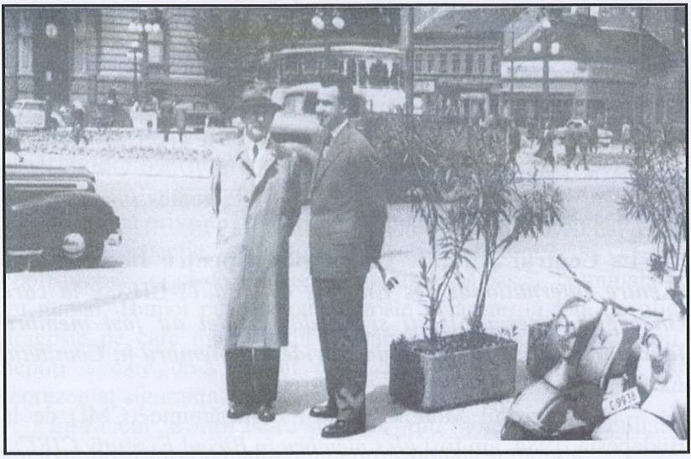
Photo 1. The 4th World Fertilizers Congress CIEC, Opatija, Yugoslavia, 1961

I think I'm an "Age Dean", the only CIEC member alive with continuous activity for 63 years.
Active participation was appreciated by the CIEC Presidium members and in 1984, at the 9th CIEC World Congress in Budapest, I was elected a member of the Presidium, and in 1996, at the Vienna General Assembly, I was elected President of CIEC (see photo 2: Triumvirat Welte, Hera, Schnug).

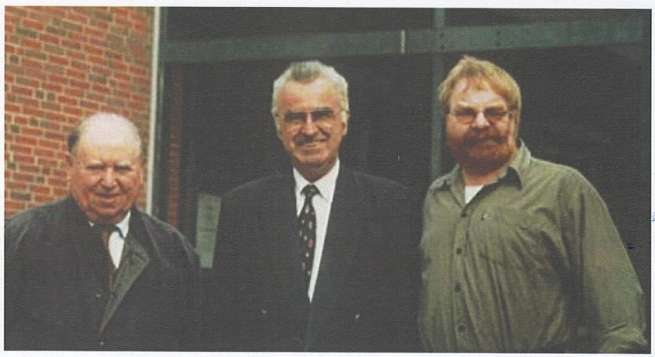
Photo 2 – A triumvirate of its own
(From left to right: Prof. Erwin Welte, Prof. Cristian Hera and Prof. Ewald Schnug)

In 1997, at the 10th CIEC Congress, Ghent, Belgium, I was validated as President CIEC, in which capacity I was reconfirmed in 2001 at World Fertilizer CIEC Congresses in Beijing, China, and in 2006 at Chiang Mai, Thailand.
After a period of 14 years, at the 15th CIEC World Congress in Bucharest, Romania, my country of origin, due to my advanced age I requested to retire from the position of President. The Presidium of the CIEC validated the request, electing me this time as Honorary President of the CIEC.
At the same meeting, the Presidium of the CIEC decided to elect Prof. Ewald Schnug as President of the CIEC, an election met with loud applause by the participants at the congress. (see photos 3, 4, 5- ”Prof. Ewald Schnug, Prof. Cristian Hera: Two governors, one voice" and photo: "Handing over the "baton" by CIEC President Prof. Ewald Schnug ").
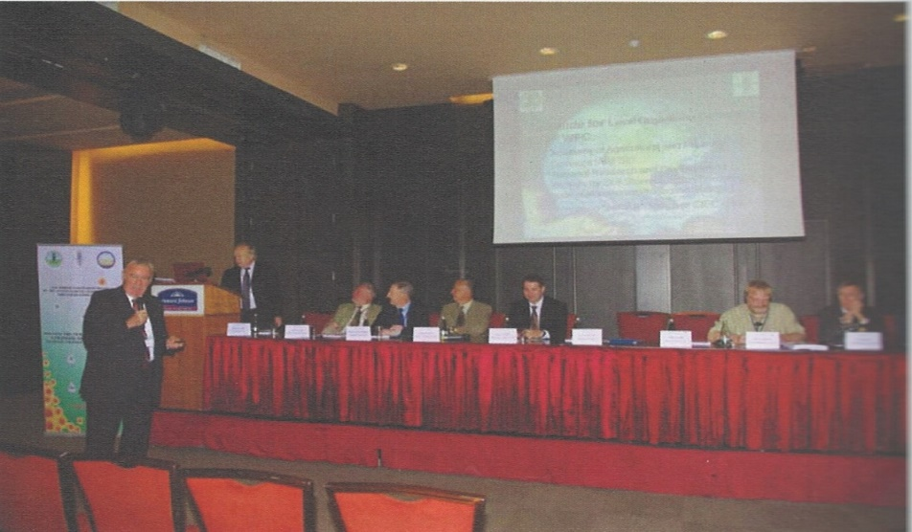
Photo 3 – the 15th CIEC World Congress, Bucharest, 2010
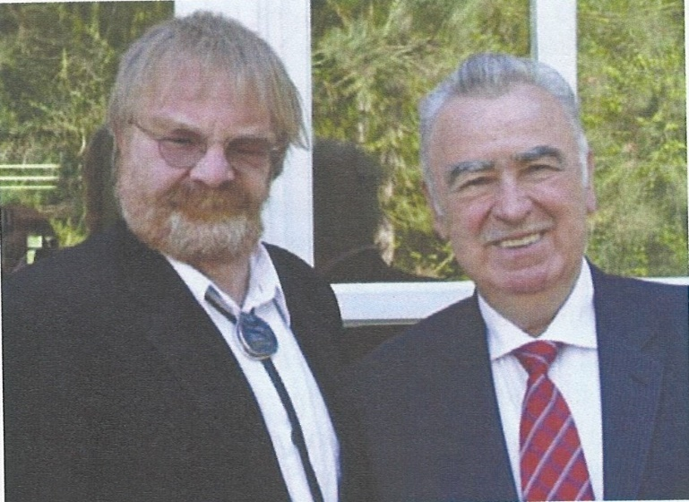
Photo 4 - Two governors, one voice
(Left: Prof. Ewald Schnug; Right: Prof. Cristian Hera)

Photo 5 – "Handing over the "baton" by CIEC President to Prof. Ewald Schnug "

At the Bucharest Congress, Brazil was nominated to organize, in 2014, the 16th CIEC congress (see photo 6 - Presidium and Hera’s opening speech).

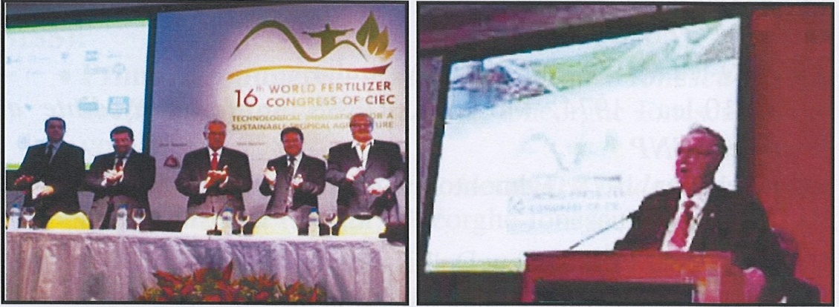
Photo 6 – Opening speech at the XVIth CIEC Congress, Rio de Janeiro, 2014

I can state without reservation that starting with this date, Prof. Ewald Schnug highlights the knowledge gained throughout his research and teaching activities, the experience gained as director and professor of the Institute for Crop and Soil Science at the Federal Research Centre for Cultivated Plants, a subsidiary of the German Federal Ministry of Agriculture and as Extraordinary Professor at the Technical University in Braunschweig, above all, the experience gained in CIEC activity as Vice-President, President and Honorary President, as well as the experience gained in other national and international organizations and bodies, for future benefits of CIEC prosperity.
As a result of our long collaboration, I affirm that Prof. Ewald Schnug is a man you can rely on.
Before finishing, please allow me to express my great joy and satisfaction with the activity carried out by the current president of CIEC, Prof. Lanhzu Ji, whom I met in 2001, during the preparation period of the 12th WFC in Beijing, to whom Prof. Ewald Schnug smoothly transferred the presidency of CIEC, in June 2020.
I wish to CIEC, the only international organization of scientists solely dedicated to the science and art of fertilization, with the longer experience and tradition worldwide, new achievements and great success in the future activities.

VIVAT, CRESCAT, FLOREAT CIEC !

Thank you very much for the attention.

Acad. Cristian HERA,

CIEC Honorary President (2010-present),

Former CIEC President (1996-2010)

